**Portfolio Management Excellence**

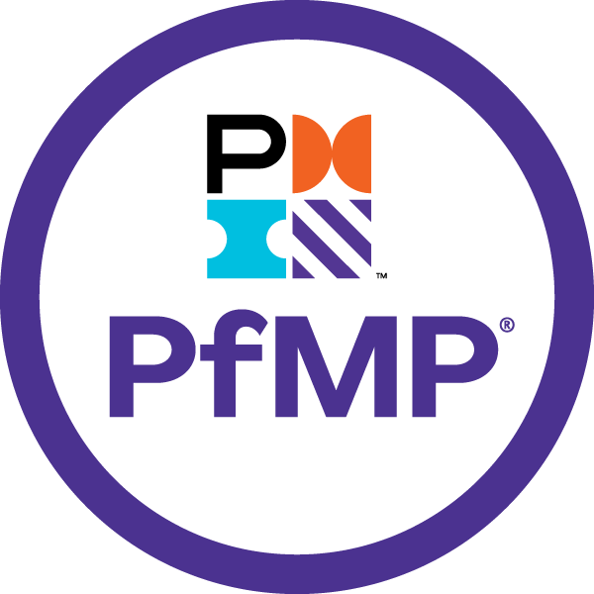

Sriram

# Sriram



I have been involved in IT Software development since 1997. I have unique combination of process, technical and industrial skills. As a Digital Leader, I have expert level of knowledge in agile and practices with this combination I can help process and technology people, understand the agile world.

The “**Portfolio** **Management Excellence”** book comprises of Portfolio Management. One in All, All in One & Key to Success.

My agile journey started in 2011, when I was a part of Tata Consultancy Services. I practiced scrum and agile methods thoroughly over several years and my teams are highly successful in delivering products using agile techniques.

I am proficient in agile engineering, coaching practices and SAFe consulting practices. I have more than 5 years of experience as a senior architect cum senior manager in development. I religiously follow key agile engineering practices like TDD, Refracting, CI and Collective Ownership. Worked in USA, UK for TCS, AtoS, Cognizant & IBM - Agile customers, which creates a global agile experience.

I moved back to India in 2016 and created agile websites and released books related to Scrum Alliance Professional, Agile Coaching and Implementing SAFe 5.0 practices.

Throughout my agile journey, I have been associated the agile professionals, who have helped and mentored me in the journey where sky is the limit.

Place: Dubai, UAE – Middle East Email: intellectsriram@gmail.com

# Table of Contents

Contents

Sriram 2

Table of Contents 3

1. Introduction to Portfolio Management 4

2. Portfolio Strategic Management 14

3. Portfolio Governance Management 26

4. Portfolio Performance Management 37

5. Portfolio Communication Management 46

6. Portfolio Risk Management 51

7. Portfolio Glossary 59

# 1. Introduction to Portfolio Management

**1.1 Project, Program & Portfolios**

* A Project is a temporary endeavor undertaken to create a unique product, service or result. Project management concentrates on achieving specific deliverables
* A Program is a group of related projects, subprograms, and program activities managed in a coordinated way to obtain benefits not obtainable from managing them individually. Programs management concentrates on realizing the expected benefits
* A Portfolio is a collection of projects, programs, and operations managed as a group to achieve strategic objectives. Portfolios management aims to maximize the value gained, optimize the resources, and accept risks as per the organizational limits

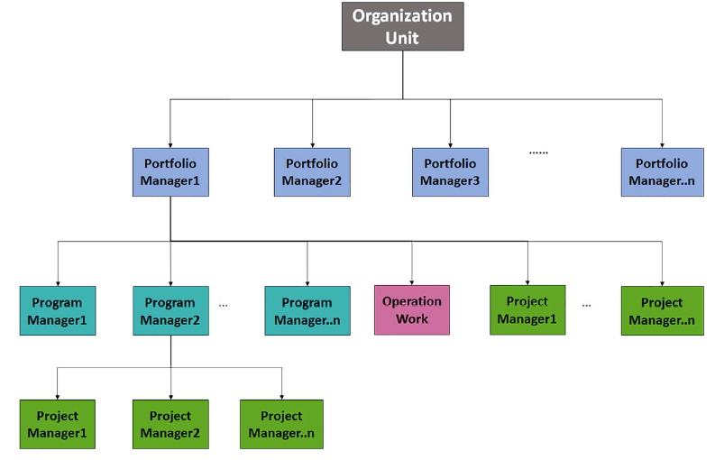

**1.2 The Portfolio**

* Should be aligned to its organizational strategy
* Should be a representation of an organization’s intent, direction, and progress
* Has a parent-child relationship with its portfolio components

**Portfolio Management**

Portfolio management is the coordinated management of one or more portfolios to achieve organizational strategies and objectives

* A governing body
* Portfolio components interrelationships
* Resources allocation
* Applied globally and across industry groups
* Generally accepted
* Should not be applied uniformly for all portfolios
* Portfolio manager determines which processes are appropriate

**Portfolio Components**

* May be projects, programs or operations
* May be sub-portfolio; which is a special type of a portfolio that is managed under another portfolio
* Not necessarily be interdependent or have related objectives
* Quantifiable, so, they can be measured, ranked, and prioritized
* Are managed and are periodically measured according to frameworks

**Portfolio Management Knowledge Areas**

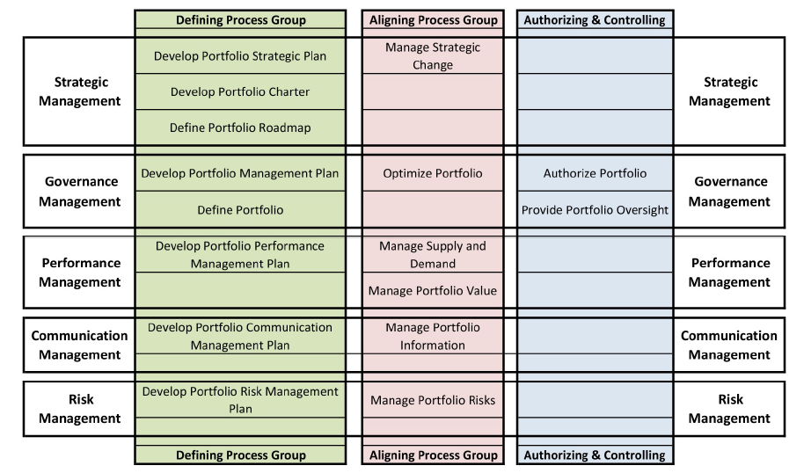

**Portfolio Management Process Groups**

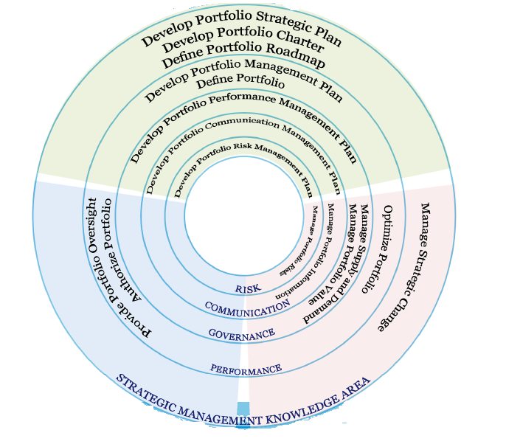

**1.2 Portfolio Management Inputs and Outputs Dictionary**

**Portfolio Process Template**

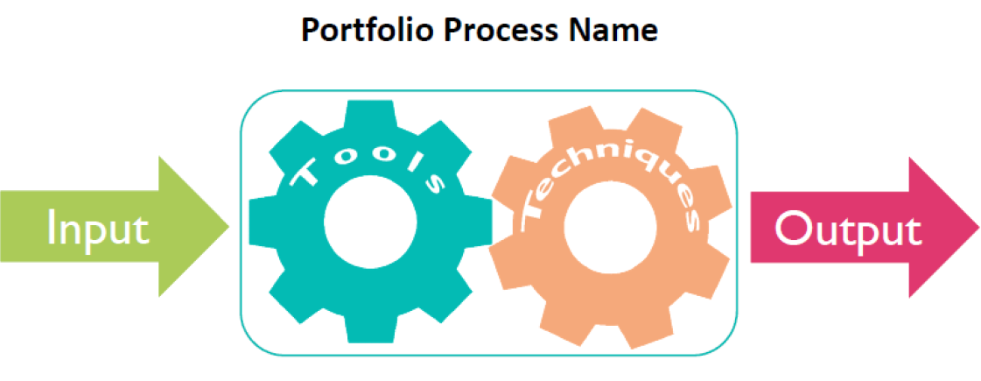

**Portfolio Management I/O Dictionary**

1. Common Inputs and Outputs
2. Key Deliverables
3. Other Inputs and Outputs

**1. Common Inputs and Outputs**

* Make portfolio management complex
* They are:
* Portfolio Process Assets
* Portfolio Reports
* Organization Process Assets
* Enterprise Environmental Factors

**Input / Output Table Chart**

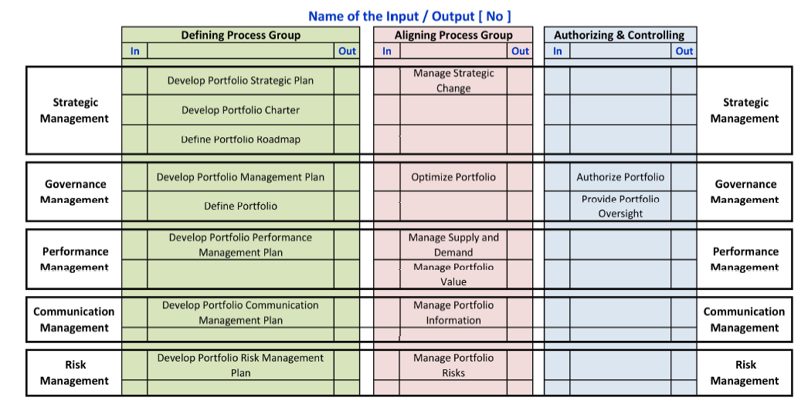

**2. Key Deliverables**

* Portfolio Strategic Plan
* Portfolio Charter
* Portfolio Roadmap
* Portfolio Management Plan

**Portfolio Strategic Plan**

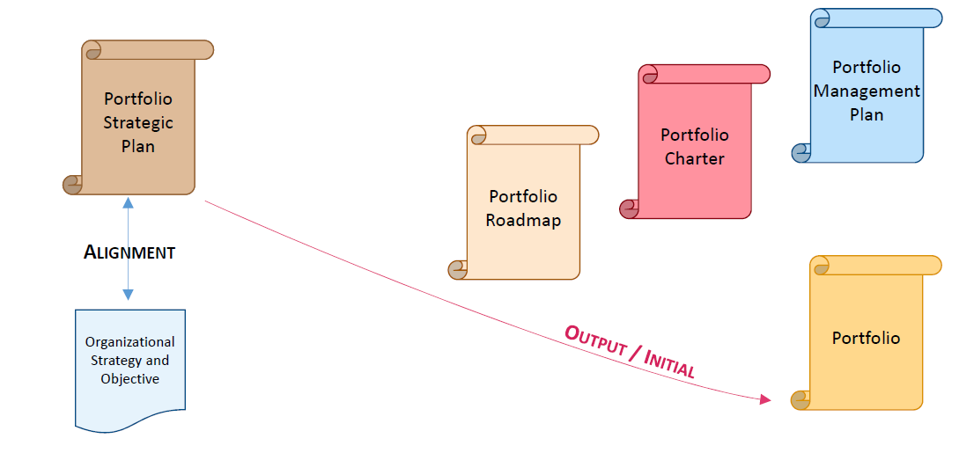

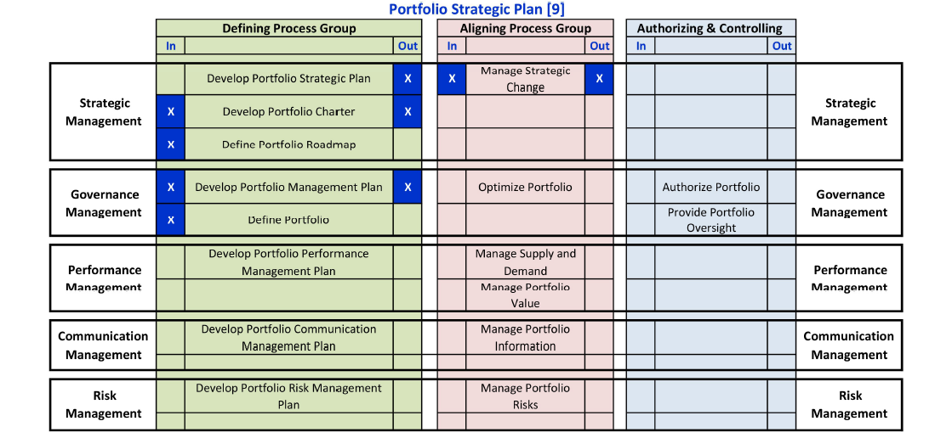

**Portfolio Charter**

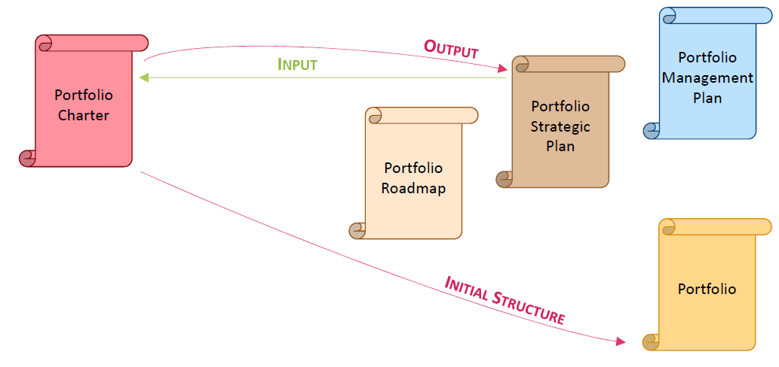

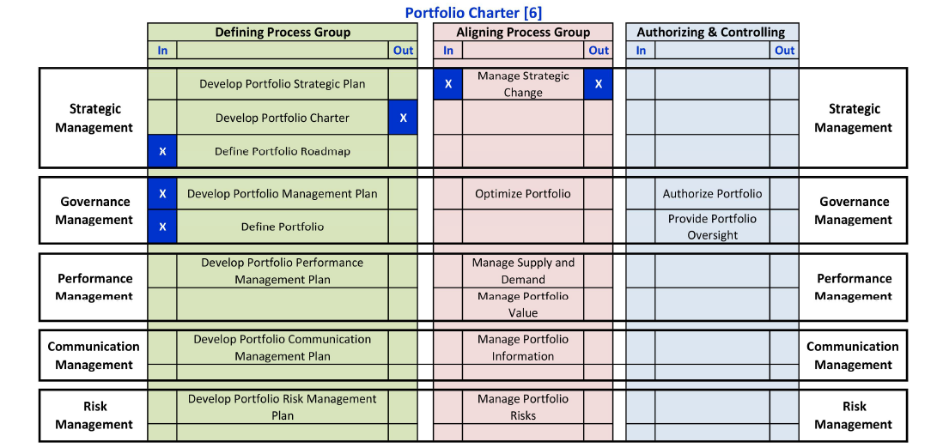

**Portfolio Roadmap**

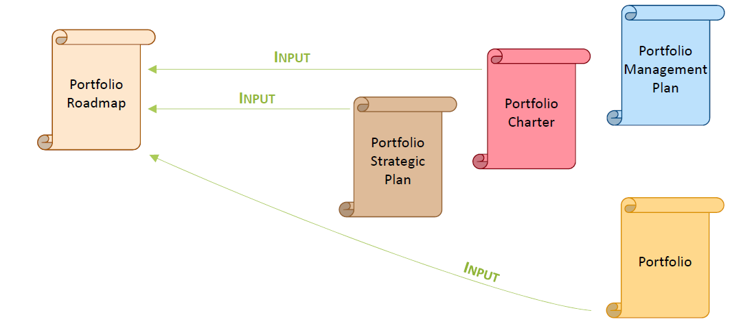

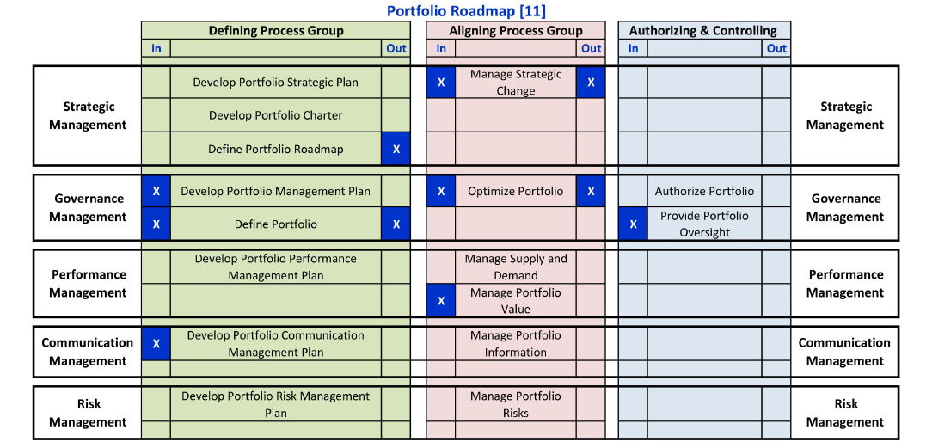

**Portfolio Management Plan**

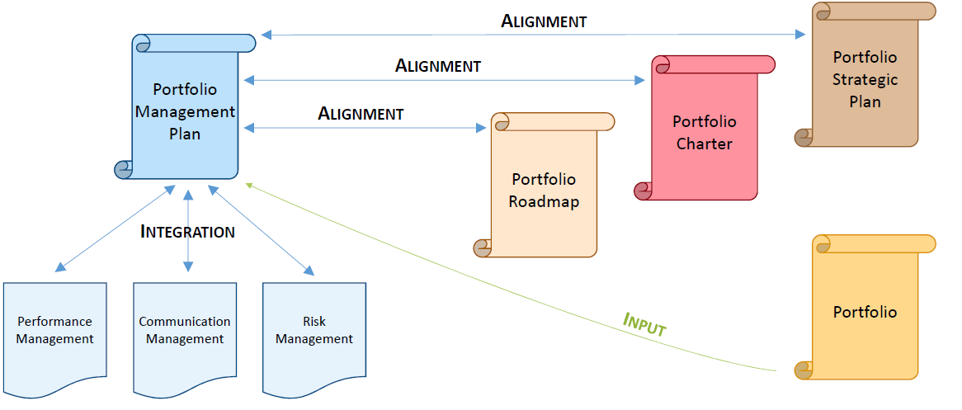

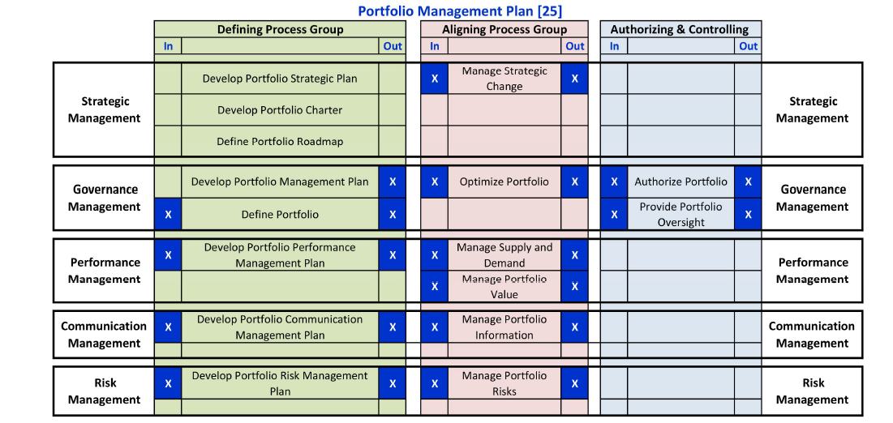

**Portfolio**

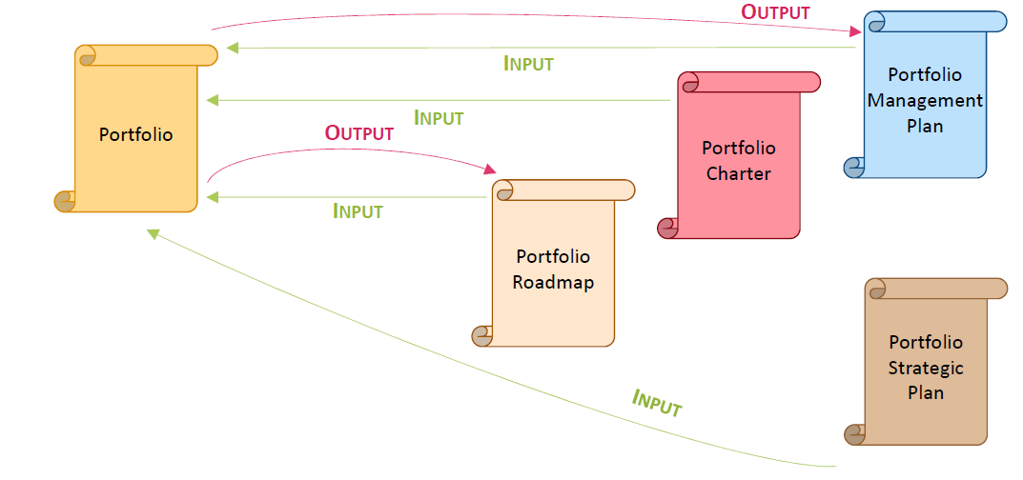

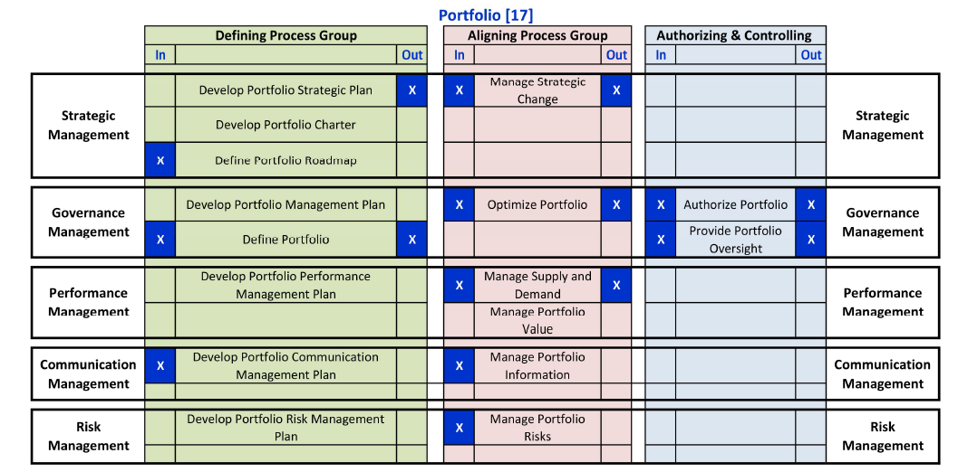

**3. Other Inputs and Outputs**

* Organizational Strategy and objectives
* Inventory of Work

# 2. Portfolio Strategic Management

**Introduction to Strategic Management**

* Portfolio Strategic Management Processes to develop:
  + Portfolio Strategic Plan
  + Portfolio Charter
  + Portfolio Roadmap
* Helps to Assess and manage the alignment of these three deliverables to the organizational strategy and objectives
* Managing, monitoring, and responding to ongoing changes in organizational strategy and in portfolio components

**Strategic Management Knowledge Area**

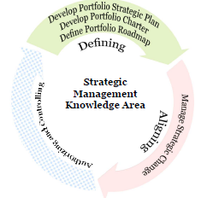

**Section – I Develop Portfolio** **Strategic Plan**

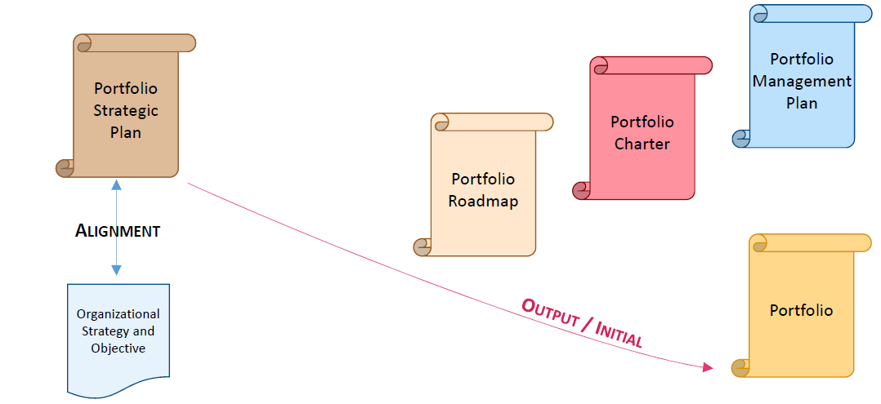

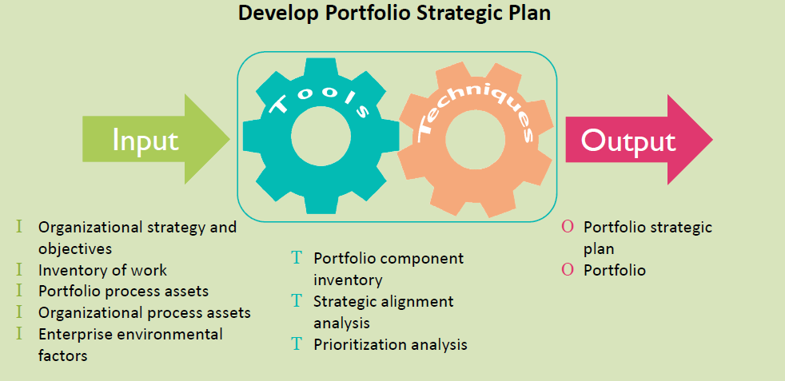

**Example: Strategic Plan Template**

**Portfolio Vision**

* Enable the organization technology to hold the first position in the mobile services market

**Portfolio Objectives**

* Enhance the existing rules and financials to comply with the new regulation rules before the given deadline
* Implement the new technology to provide better mobile services to our customers
* Add new billing channels to increase the revenue and get more customer satisfaction
* Increase the organization market share

**Resources**

* Funds: portfolio components budget should not exceed $ 32.2 M in 2017 and 2018
* Functional managers will avail internal resources to contribute to this portfolio components
* Department heads will provide resources to support the planning and contracting phase

**Initiatives**

* Comply with the new telecommunications regulation
* Open new billing channels in the Billing system
* Enhance the software and the hardware to be more competitive
* Penetrate new marketing

**Portfolio Benefits**

* Increase the market share by 12%
* Open 3 new Billing Channels
* New regulation compliance

**Portfolio Value Expected**

* Increase the Market Share by 12% by end of 2018
* Comply with the new regulations by Q2 2018

**Communication Requirements**

* Hold Portfolio Review meeting monthly with the Board of Directors
* Establish steering committee for each program in the portfolio and to have at least one member of the Board of Directors

**Assumptions**

* New regulations will not be changed before mid-2018
* Existing market surveys will be used to understand the customer requirements

**Constraints**

* Compliance with the regulations should be completed before end of Q2 2018
* No overtime is accepted, but bonus on achieved objectives is allowed

**Dependencies**

* Billing system enhancements will depend on the network enhancements
* Regulation compliance will mandate changes in the current financial system

**Risks**

* New unproven technology may be unstable
* Regulation authority may add new rules before end of 2017
* Organization capacity problem because of the new initiatives

**Portfolio Structure**

* Marketing Campaign Program
* New Billing Program
* New Network Devices Implementation Program
* Regulation Compliance Project
* Financial System Updates Project
* IT Operation Management

**Portfolio Prioritization Model**

* Scoring techniques will be used in the Technology Portfolio
* The compliance with the regulation objective – Score Weight of 30%
* The time constraints of the related organization objectives – Score Weight of 25%
* Dependencies between the Portfolio Components – Score Weight of 15%
* Utilizing internal resources – Score Weight of 10%
* Saving funds to the Portfolio – Score Weight of 10%
* The customer Surveys – Score Weight of 10%

**Section 2 - Develop Portfolio** **Charter**

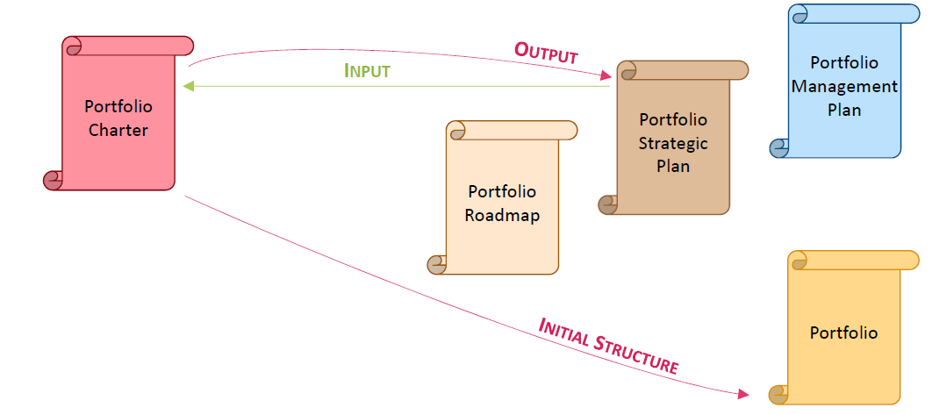

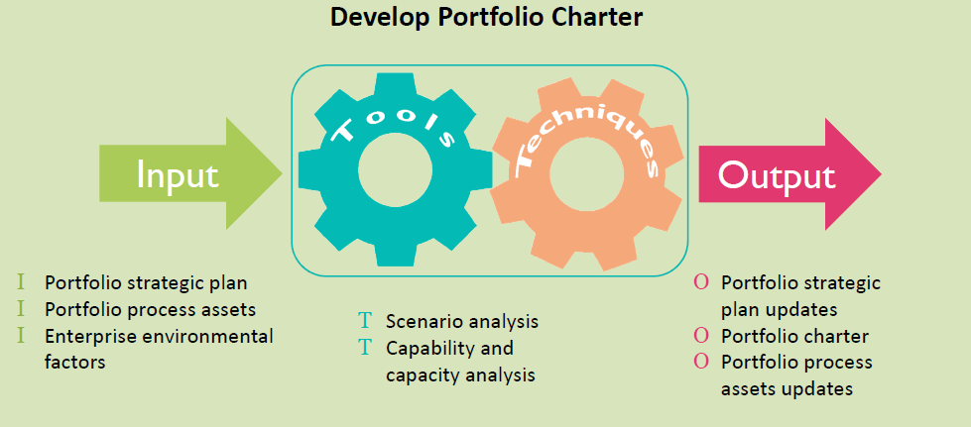

**Example – Portfolio Charter Template**

This document formally authorizes Mr. James as the portfolio manager to the Technology portfolio and allows him to allocate resources to the portfolio component.

**Portfolio Sponsor**

* Mr. Allan, the CFO, is appointed as the Technology Portfolio Sponsor

**Portfolio Structure**

The Technology portfolio has the following components:

* Marketing Campaign Program
* New Billing Program
* New Network Deceives Implementation Program
* Regulation Compliance Project
* Financial System Updates Project
* IT Operation Management

**Major Stakeholders**

* Board of Directors members
* C-level managers
* Organization Heads of Departments
* Component sponsors
* Component managers

**Communication Requirements**

* Bi-weekly portfolio component review with the portfolio manager
* Weekly status report for each portfolio component

**Critical Success Factors**

* Team work
* Leadership and experience of the component manager
* On time and accurate status reporting for the portfolio and its components to support decision making

**High Level Timelines**

* Billing Transformation Program to be completed by end of 2018
* Regulation Compliance to be live by Q2 2018
* New Network Devices Implementation to go live by Q2 2018
* Financial System Updates to be completed by Q2 2018
* IT Operation Management to comply with the ITIL by end of 2017

**High Level Scope**

* Marketing Campaign to penetrate the market and increase the market share
* New Billing system with new billing channels (at least three new channels)
* New Network devices Implementation Program
* New Organization Regulations which are complied with the new regulations from the telecommunication authority
* Financial System enhancements as per the organization requirements
* IT Operation Management processes and procedures to comply with ITIL

**Assumptions**

* New regulations will not be changed before mid-2018
* Existing market surveys will be used to understand the customer requirements

**Constraints**

* Compliance with the regulations should be completed before end of Q2 2018
* No overtime is accepted, but bonus on achieved objectives is allowed

**Dependencies**

* Billing system enhancements will depend on the network enhancements
* Regulation compliance will mandate changes in the current financial system

**Risks**

* New unproven technology may be unstable
* Regulation authority may add new rules before end of 2017
* Organization capacity problem because of the new initiatives Develop Portfolio

**Section – III Develop Portfolio** **Roadmap**

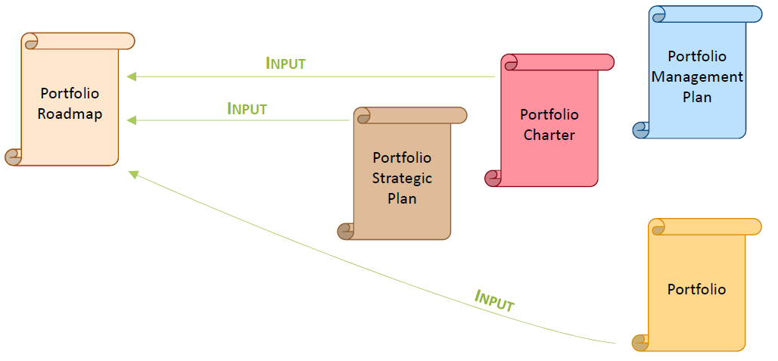

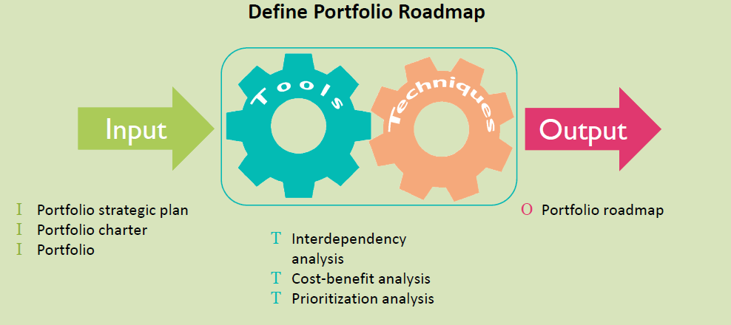

**Portfolio Roadmap**

* High-level strategic direction and information in a chronological fashion for portfolio
* management
* Graphically depicts all portfolio elements
* Program level and project level roadmaps
* Initial basis on which dependencies are established
* High-level prioritization mapping of the portfolio over time

**Roadmap includes:**

* List of components
* Components Dependencies and major risks
* Components High level timeline
* Key milestones and deliverables
* Components prioritization

**Example – Portfolio Roadmap**

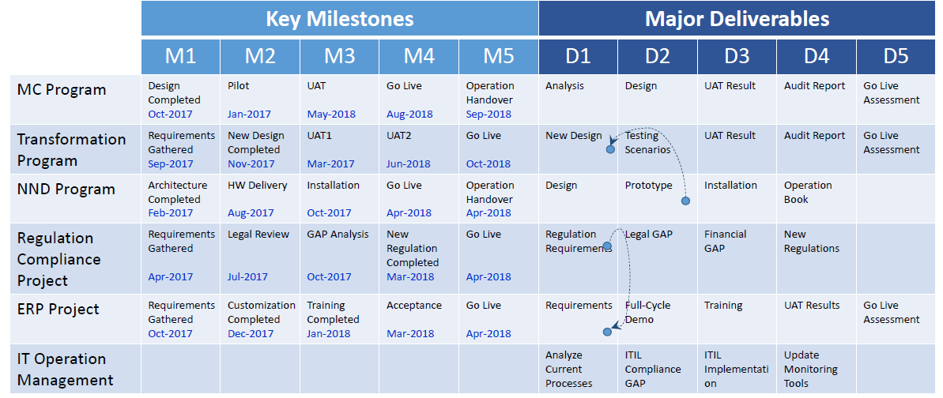

**Section IV Managing Strategic Change**

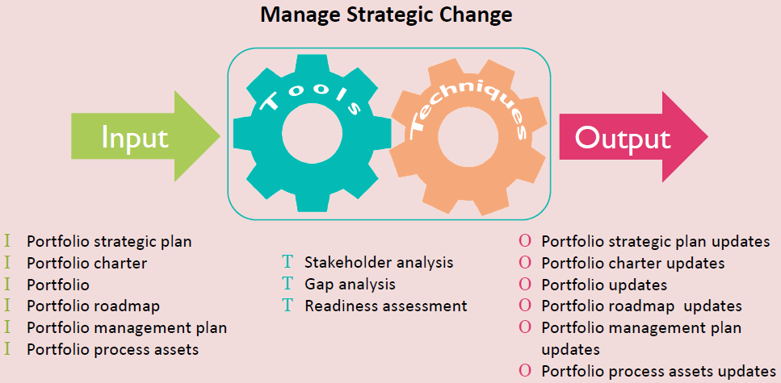

# 3. Portfolio Governance Management

**Portfolio Governance Management**

The processes in the Portfolio Governance Management are responsible for Developing the Portfolio Management Plan, allocating resources and authorizing the portfolio components

* Optimizing the portfolio
* Monitoring and reporting the progress

**Governance Management Knowledge Area**

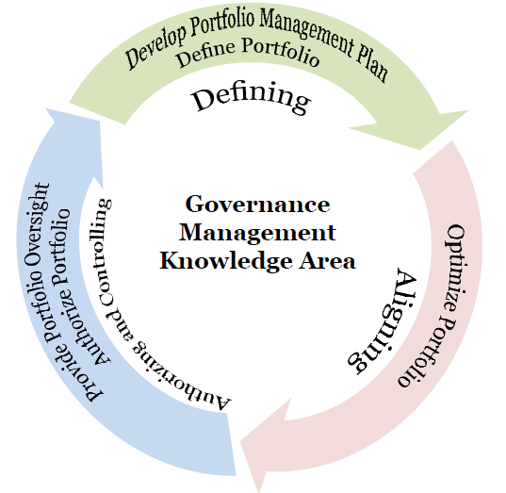

**Develop Portfolio Management Plan**

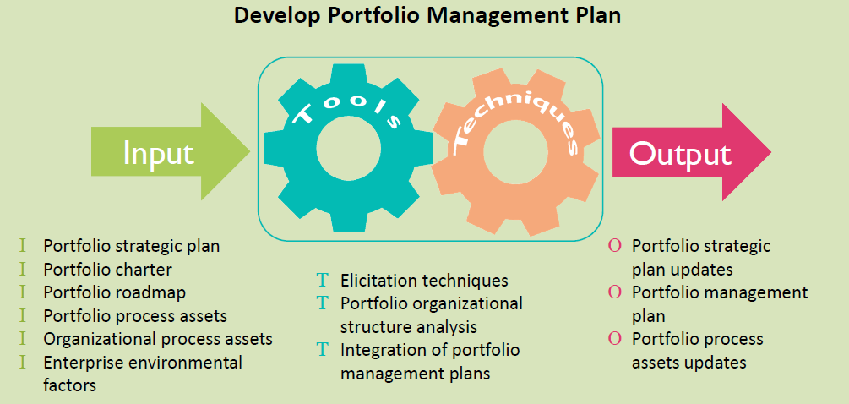

**Portfolio Management Plan**

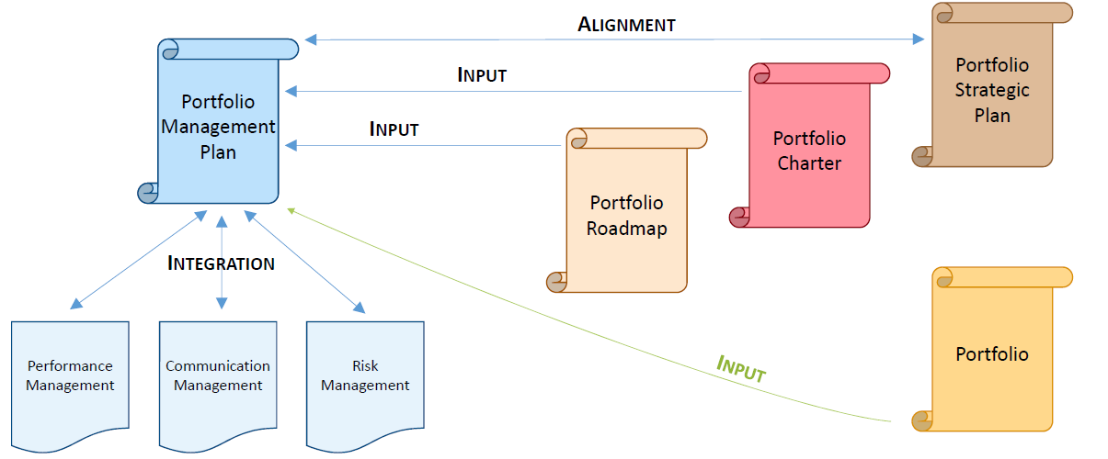

**Example - Management Plan**

**Governance Model**

* Component manager is direct reporting to the Portfolio Manager
* Component manager is getting portfolio sponsor support in organization resource allocation and in executing his component roadmap
* Internal resource allocation will be suggested by the functional manager and approved by the component manager
* Missing resources to be escalated to the Portfolio manager by the component manager
* Major component risks and issues will be escalated to the portfolio manager during the review meetings and status reporting

**Portfolio Oversight**

* Portfolio KPI’s are created by the portfolio management team, reviewed and agreed by the Organization Center of Excellence
* Portfolio external/internal audit will be executed on the agreed components
* Portfolio dashboard will be distributed to the portfolio sponsor to review the portfolio KPI’s

**Managing Strategic Change**

* Strategic change will lead to portfolio review to ensure compliance with the new strategic changes or to define the gap to be closed
* If gap found portfolio manager will assess the change and create implementation plan with the help and commitments of the component changes
* Portfolio sponsor will accept the strategic change plan before implementing it
* Details of the managing strategic change process is described in a separate document

**Change Control and Management**

* Changes within the portfolio agreed scope, schedule and deliverables are controlled by the change control process
* Impact analysis is required for the change, then change approval is obtained as per the approval process
* Details are covered in the change control process which is described externally to this document

Three subsidiary plans are connected to the Portfolio Management Plan:

* Performance Management Plan
* Communication Management Plan
* Risk Management Plan

**Procurement Planning**

* Portfolio procurement is executed as per the organization regular procurement process
* The portfolio is handled as a separate cost center which is managed by the portfolio manager and all procurements should be approved by him

**Portfolio Prioritization Model**

* Scoring techniques will be used in the Technology Portfolio
* The compliance with the regulation objective – Score Weight of 30%
* The time constraints of the related organization objectives – Score Weight of 25%
* Dependencies between the Portfolio Components – Score Weight of 15%
* Utilizing internal resources – Score Weight of 10%
* Saving funds to the Portfolio – Score Weight of 10%
* The customer Surveys – Score Weight of 10%

**Define Portfolio**

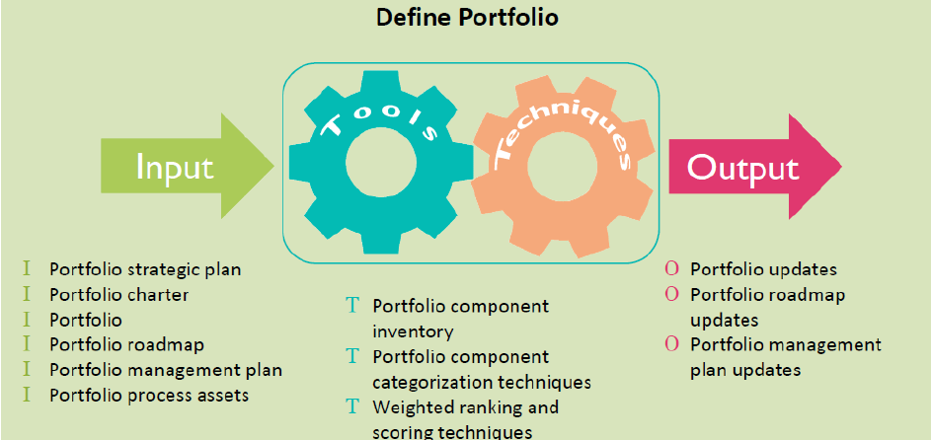

**Define Portfolio – Major Activities**

* Identifying qualified portfolio components
* Categorizing portfolio components
* Evaluating portfolio components

**Portfolio Component Inventory**

Key descriptors may include: -

* Portfolio component number
* Portfolio component code
* Portfolio component description
* Type of portfolio component
* Strategic goals supported
* Quantitative benefits
* Qualitative benefits
* Portfolio component customer
* Portfolio component sponsor
* Key stakeholders
* Resources required

**Portfolio Component Categorization Techniques**

* Evaluation criteria should be quantifiable
* Evaluation criteria examples:
* Increased profitability
* Risk reduction
* Efficiency improvement
* Regulatory/compliance
* Market share increase
* Process improvement
* Continuous improvement
* Foundational
* Business imperatives
* Descriptors and criteria are used for filtering the portfolio components

**Portfolio**

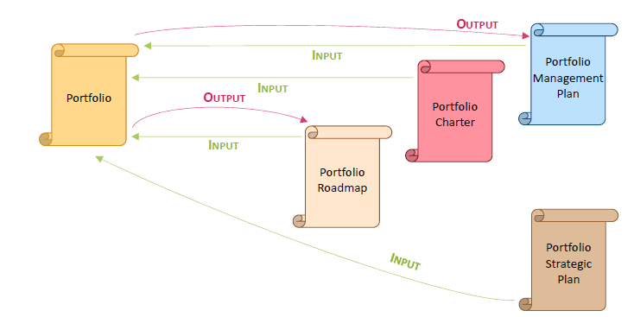

**Technology Portfolio Example**

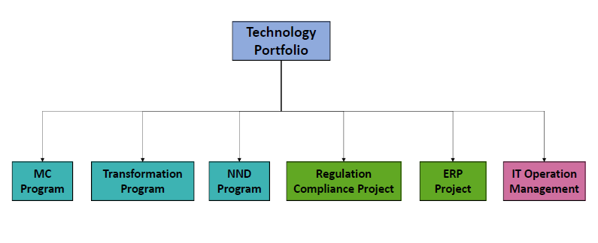

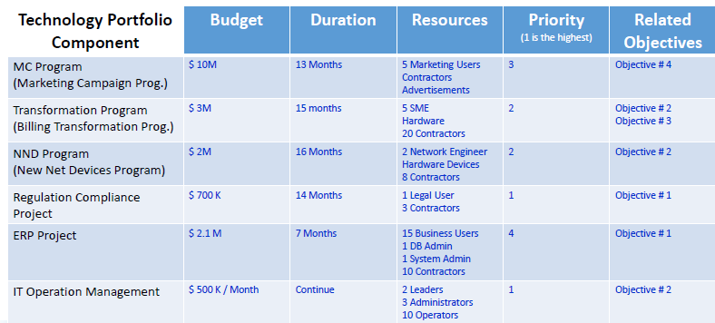

**Optimize Portfolio**

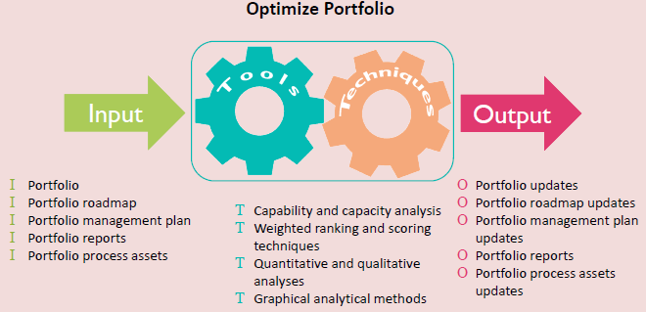

**Optimize Portfolio – Major Activities**

* Assigning or reassigning, scoring, or weighting criteria for ranking portfolio components
* Performing risk analysis on portfolio components
* Evaluating and determining performance and expected value of portfolio components
* Determining resource capability and resource capacity available
* Determining constraints for portfolio components
* Determining which portfolio components priority
* Identifying portfolio components to be suspended, reprioritized, or terminated

**Graphical Analytical Methods – Bubble Chart**

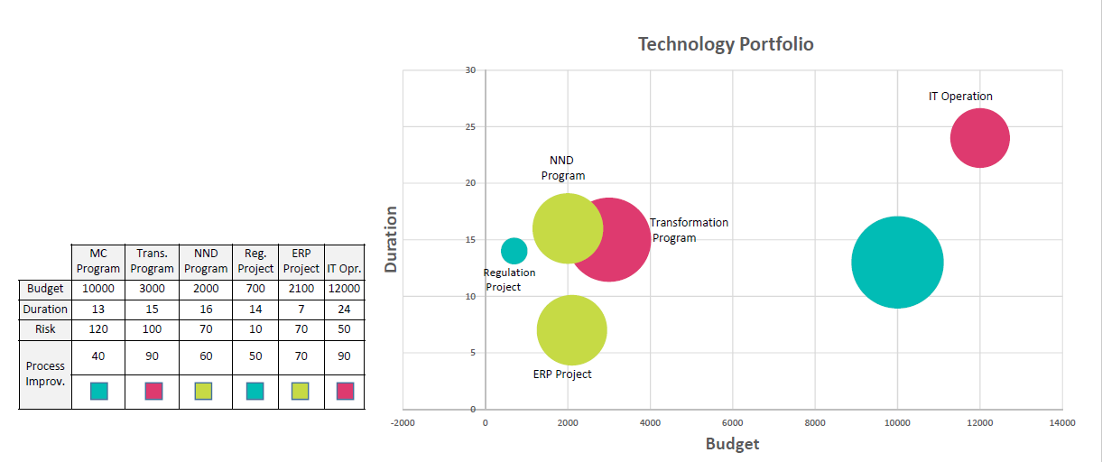

**Authorize Portfolio**

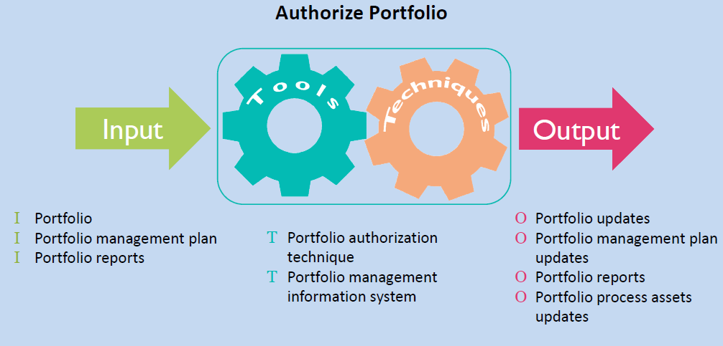

**Authorize Portfolio – Major Activities**

* Authorizing portfolio component proposal development or portfolio component execution
* Allocating resources to authorized portfolio components
* Reallocating funding and resources from deactivated and terminated portfolio components
* Communicating changes and decisions for the authorized portfolio components Authorize Portfolio

**Provide Portfolio Oversight**

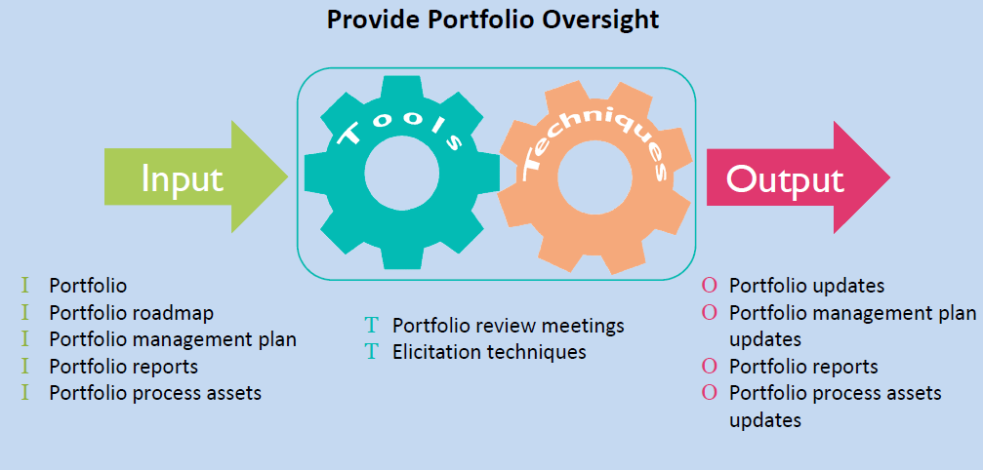

**Provide Portfolio Oversight – Major Activities**

* Reviewing information
* Conducting governance meetings
* Ensuring compliance with organizational standards
* Reporting portfolio changes and information
* Communicating governance decisions Provide Portfolio

# 4. Portfolio Performance Management

Portfolio performance management plans, measures and monitors the organizational value of a portfolio in a systematic manner, based on the achievements against strategic goals. Part of the process of portfolio performance management is to manage how key resources, such as human resources, finances and assets are sourced to obtain optimal results.

It must be linked to organizational strategy as well, which is expressed through its vision and mission, taking into account an organization’s orientation to market, environmental factors and competition. Through an effective organizational strategy, an entity will be able to define directions for development and growth, and performance metrics for success.

For easy portfolio performance management, best practices for dashboards should be followed:

* A singular dashboard should not contain too many KPIs. Break them down into separate dashboards based on common performance metrics.
* Present a dashboard in a clutter-free and organized manner. When using chart tiles, for example, keep tile sizes uniformed.
* Highlight specific data point that need to stand out.
* Take advantage of all the tools you can integrate with a dashboard, such as drill down, tool tip, zoom, filter and color adjustment.

**Portfolio Management Process**

* Develop Portfolio Management Plan: Developing the performance management plan as to how portfolio value is defined and realized through the portfolio measurements and targets, alignment to organizational strategy and objectives, and roles and responsibilities in executing the plan
* Manage Supply and Demand: Identifying and allocating the required portfolio resources capacity and capabilities according to each component proposal or plan
* Manage Portfolio Value: Measuring, capturing, validating and reporting portfolio value at an aggregate level delivered by the portfolio components with the goal of maximizing the return on investment

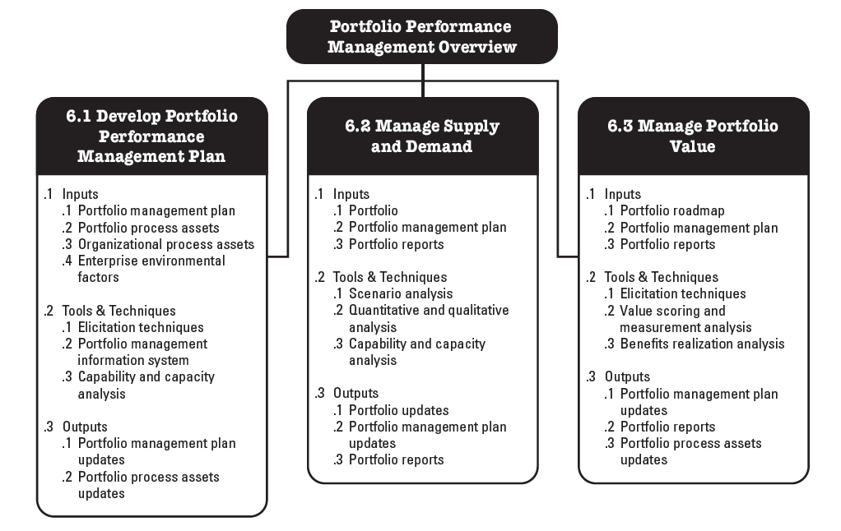

**6.1 Develop Portfolio Management Plan**

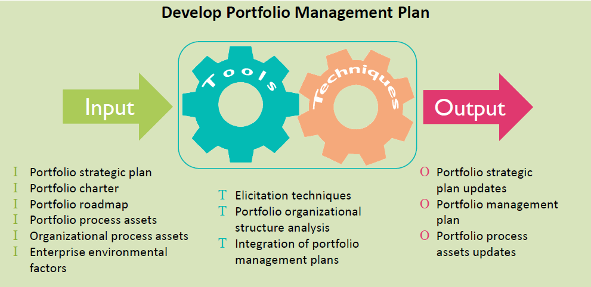

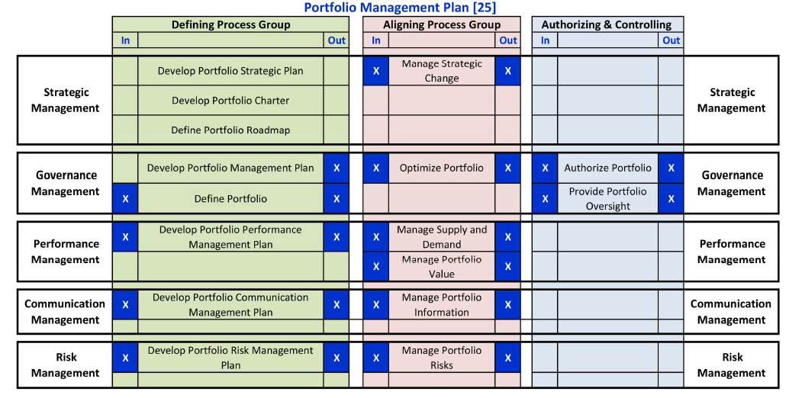

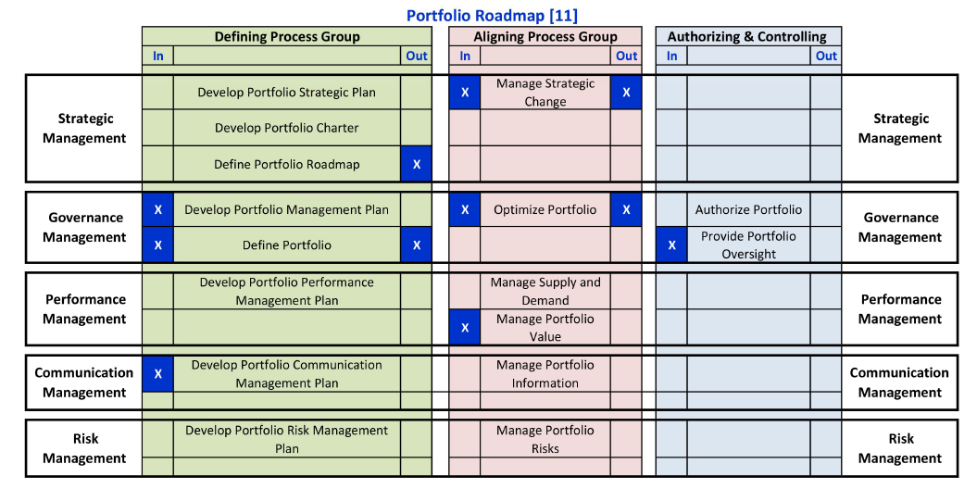

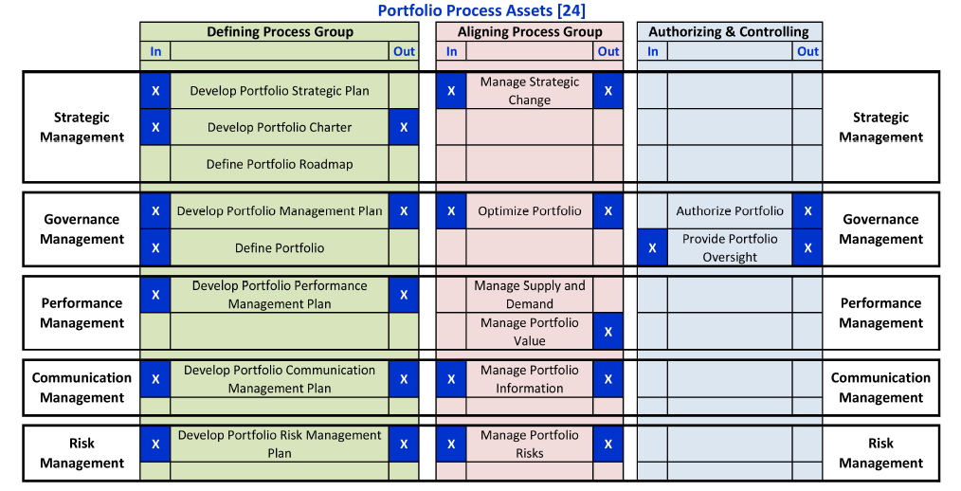

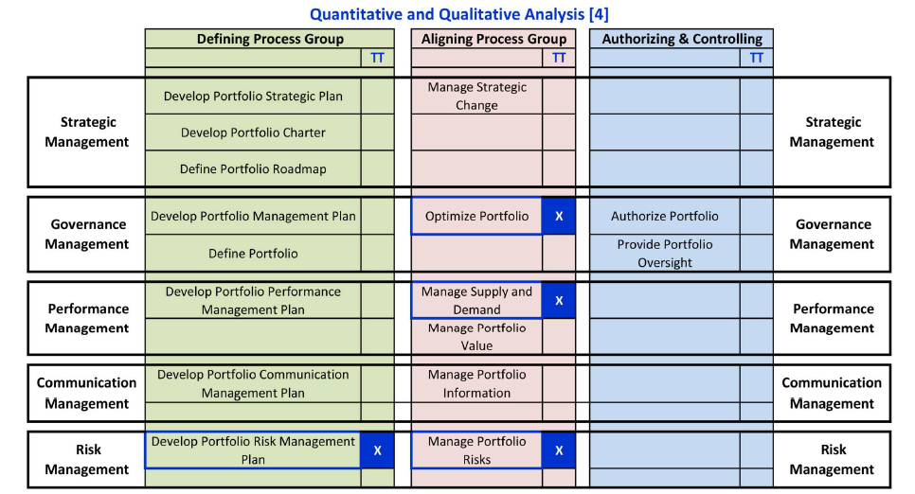

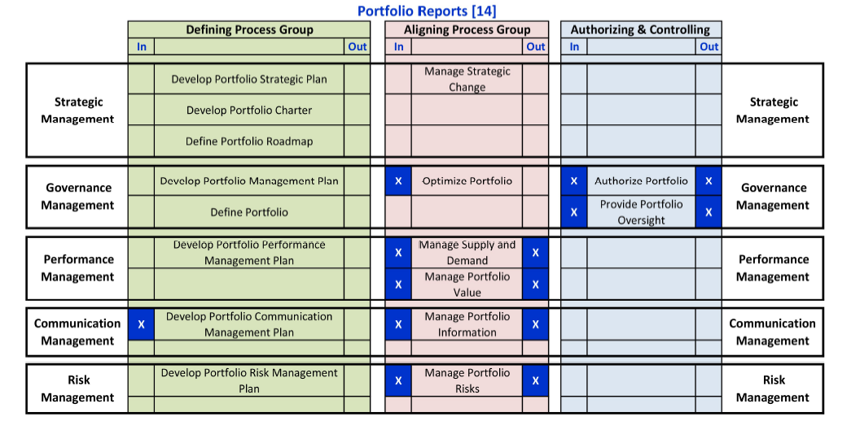

**6.2 Manage Supply and Demand**

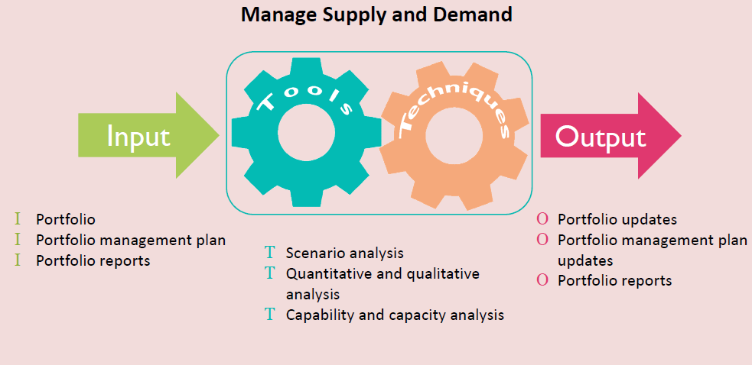

**6.3 Manage Portfolio Value**

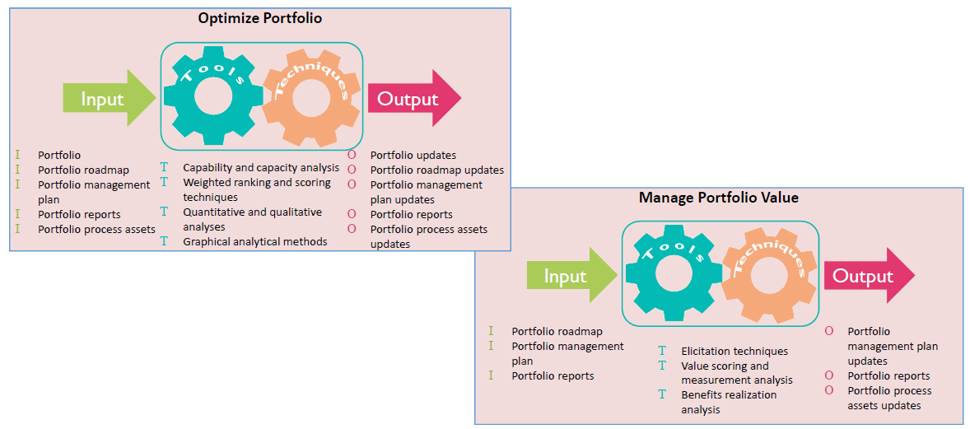

**Portfolio Success Through Effective Portfolio Performance Management**

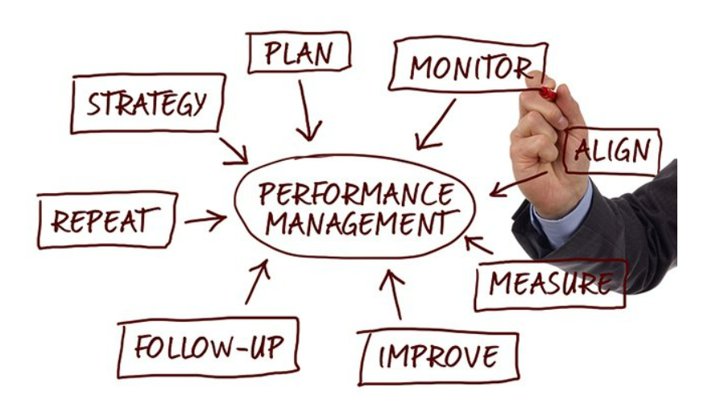For portfolio performance management to be successful, sponsors, stakeholders and portfolio managers should well-versed on what portfolio management entails. The focus is to achieve organizational strategies and objectives, but the problem is that implementation could take months or years, and usually spans across the entire organization. So, measuring and achieving portfolio success is often complex, time-consuming and labor-intensive.

But there are ways to measure success. According to the Project Management Institute (PMI), the success of a portfolio is measured in terms of the performance of aggregate investment, and the benefits resulting from a portfolio. This means measurement happens over an extended period, depending on the lifespan of a portfolio. Benefits, on the other hand, refer to those that arise from a portfolio’s associated business case that promise benefits. Most of the time, they are realized after a project or program is closed.

**Portfolio Success Criteria & Factors in Portfolio Performance Management**

**What better way to measure a portfolio’s success than to use a set of criteria?**

In a seminal paper written in 1952, Harry Markowitz laid down the foundation for the Modern Portfolio Theory (MPT) that helps determine the specific mix of investments that will generate the highest return, given an acceptable level of risk.

The four criteria are:

* Financial value of a portfolio
* Strategic success
* Selecting and Balancing
* Project success

Together they create a portfolio performance management plan that is designed to maximize a portfolio’s financial value, link its success to organizational strategy, create a balance between the projects within a portfolio and an organization’s capacity, and to achieve as much as the average single project success.

While a success criterion matters in portfolio performance management, nothing is more critical than a portfolio’s success factor that, according to Bolles & Hubbard (2007), influences a portfolio’s successful implementation within an organization. If all success factors are addressed and followed, portfolio success is guaranteed.

Portfolio success factors include, but not limited to:

* Total support and commitment from top executives, particularly in decision-making approach.
* Effective and clear communication of strategic objectives, so everyone across the organization is well-aware of the decision-making process and organizational goals.
* Strategic alignment of the investment selected with the framework to be used.
* An institutionalized management process to facilitate constant evaluation.
* Align decision-making with governance framework.
* Create an integrated discipline of program/project management
* Risk and performance measurement at a consistent and continuous level
* Review portfolios in support of realigning investment priorities
* Balance investments effectively
* Turn strategy into operational excellence
* Components prioritization is also a key success factor in the Portfolio performance management process. There is a positive relation among portfolio selection, strategy success and project portfolio performance.

# 5. Portfolio Communication Management

**Portfolio Communication Management Knowledge Area**

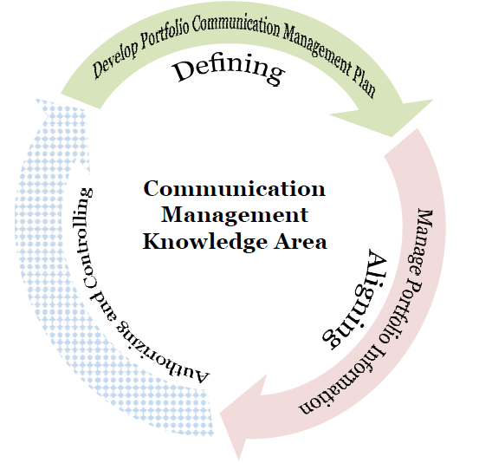

**Develop Portfolio Communication Management Plan**

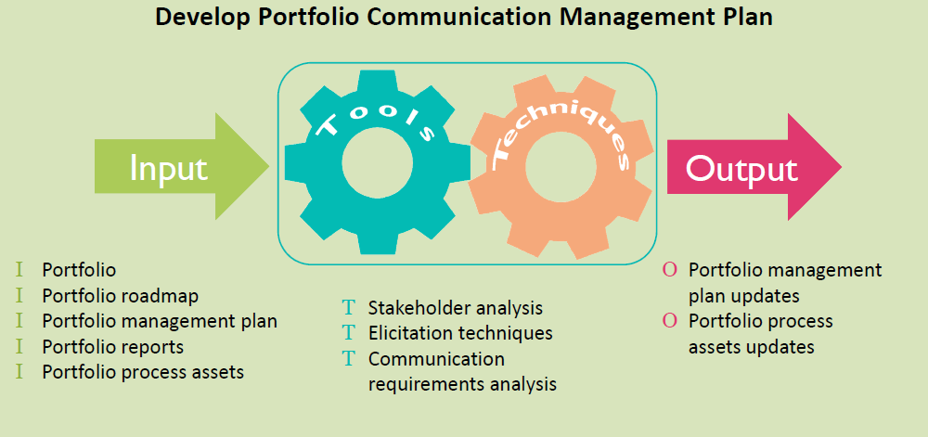

**Stakeholder Analysis**

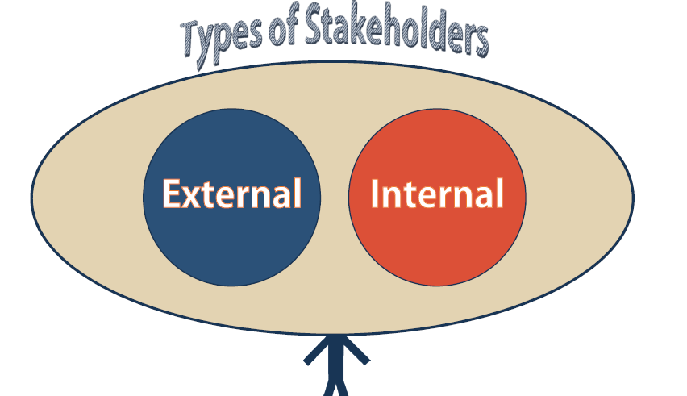

**Stakeholder Communication Strategy Matrix**

Stakeholder Communication Strategy Matrix

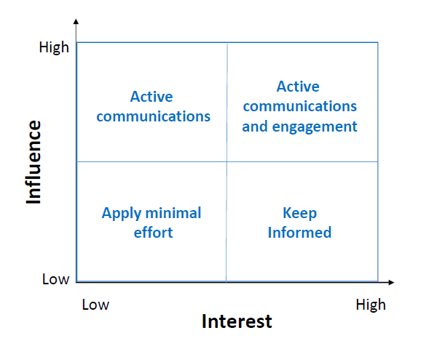

**Stakeholder Matrix Example**

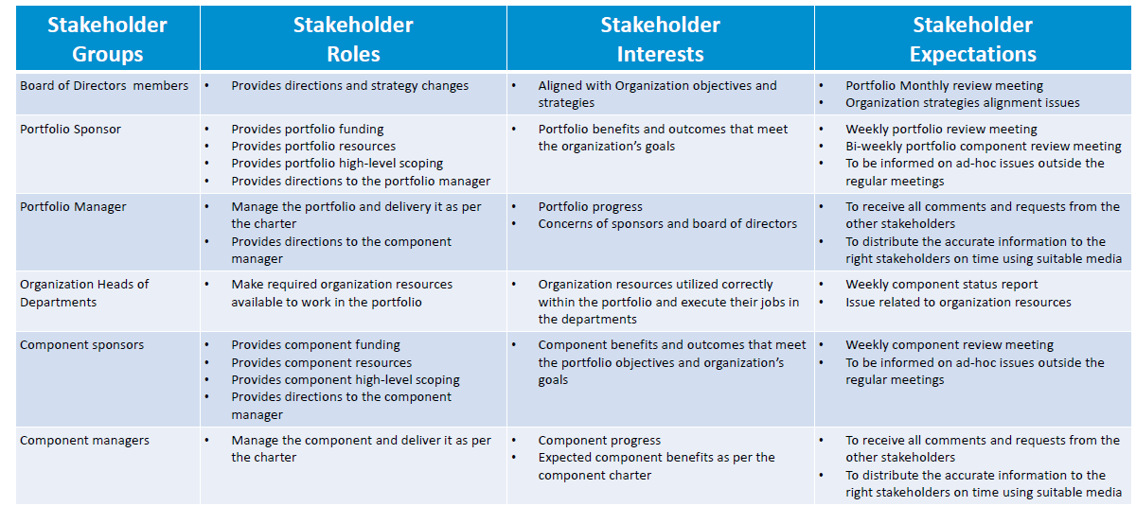

**Communication Management Plan**

The Portfolio Communication Management Plan includes: -

* Communication objectives
* Roles and responsibilities for managing communication
* Stakeholders and their expectations
* Planned methods to collect and store communication
* Planned tools to access and deliver communication
* Planned frequency
* Communication policies/constraints
* Portfolio Stakeholder Engagement Plan Develop

**Manage Portfolio Information**

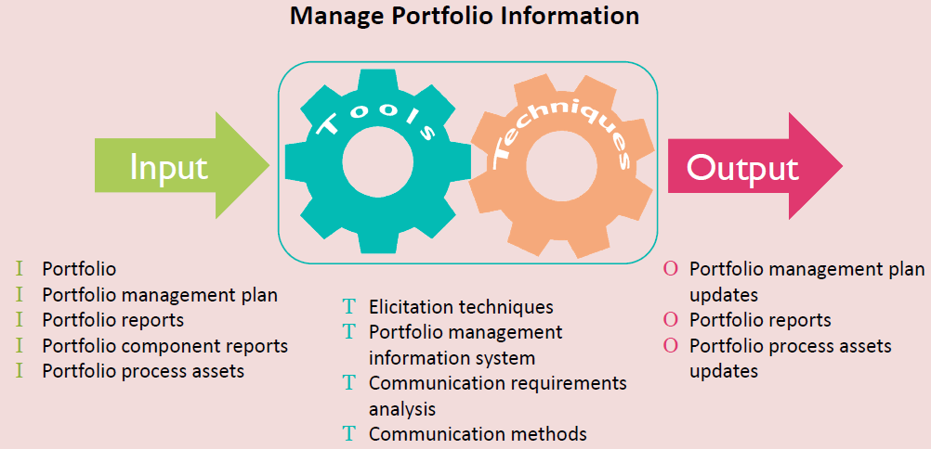

**Communication Methods**

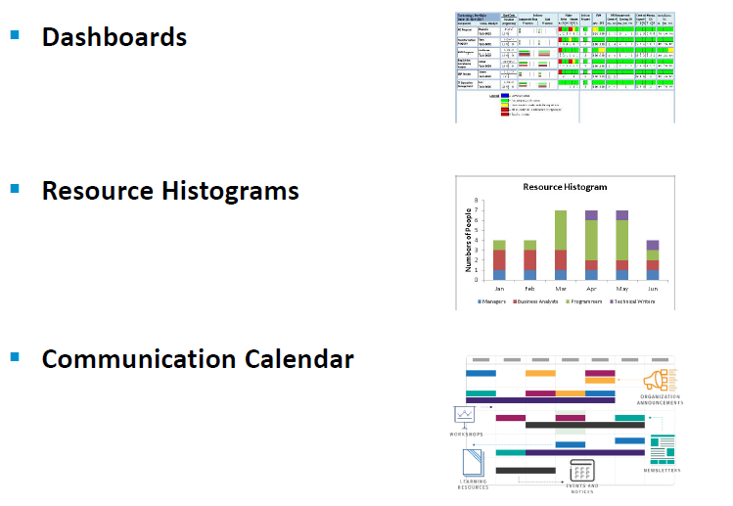

**Technology Portfolio - Dashboard Example**

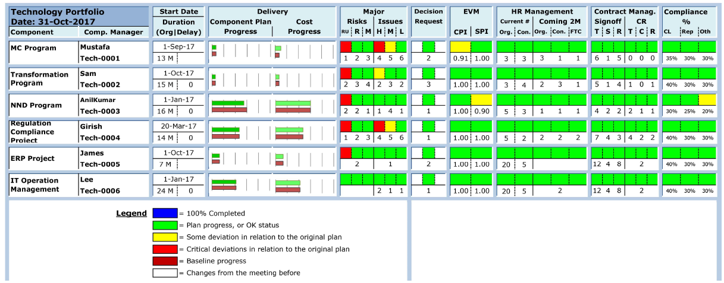

# 6. Portfolio Risk Management

**Portfolio Risk Management Knowledge Area**

* Has processes responsible for assessing and analyzing portfolio risks
* Risk management is critical where interdependencies exist or when risks from one portfolio component raise the risks in another
* Risk management may generate new portfolio components as well Portfolio Risk is concentrated on:
* Maximizing financial value of the portfolio
* Tailoring the fit of the portfolio to the organizational strategy and objectives
* Determining how to balance the programs and projects within the portfolio given the organization’s capacities and capabilities
* Portfolio risks are more than just the sum of the portfolio component risks

**Portfolio Risk Management Knowledge Area**

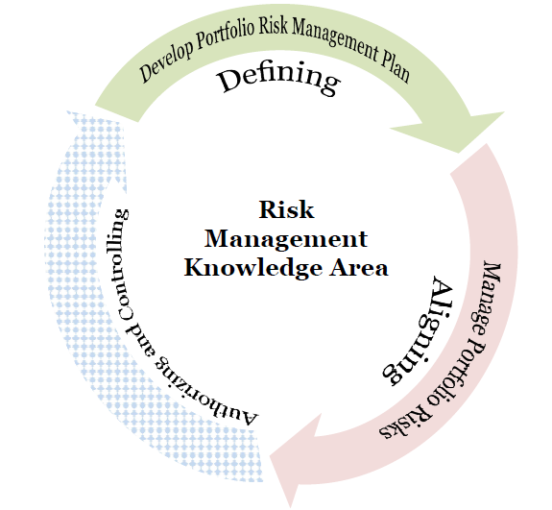

**Risk Appetite, Tolerance, and Threshold?**

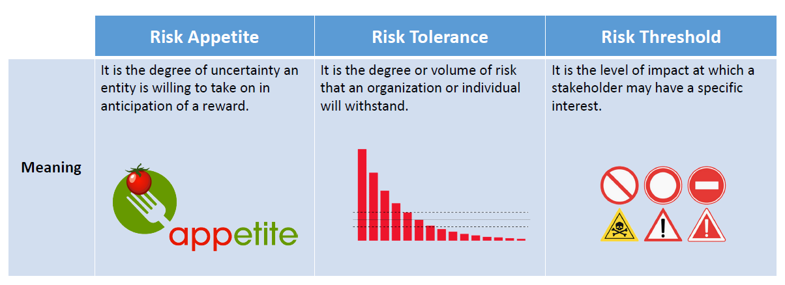

**Develop Portfolio Risk Management Plan**

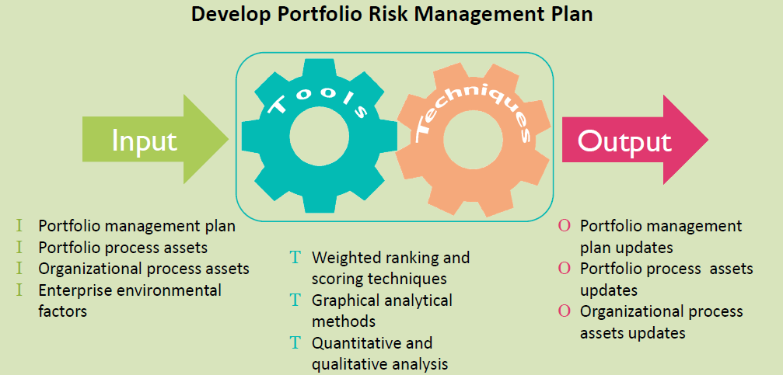

**Graphical Analytical Methods**

* Graphical Analytical Methods used to Measure the portfolio risks

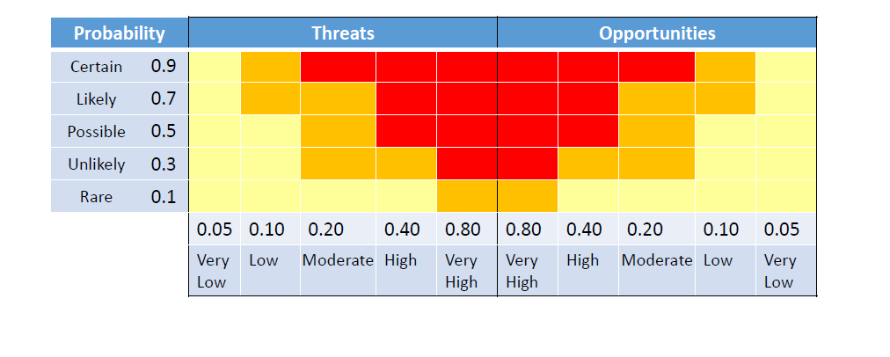

**Risk Terminology**

* Secondary Risk
* Residual Risk
* Black Swan
* Watch list
* Response Plan

**Quantitative and Qualitative Analyses**

* Status and trend analysis
* Rebalancing methods
* Investment choice tools:
  + Trade-off analysis
  + Market-payoff variability
  + Budget variability
  + Performance variability
  + Market requirement variability
  + Time-to-market variability
* Portfolio risk exposure charts
  + Outcome probability analysis of the portfolio
  + Probability of achieving portfolio objectives

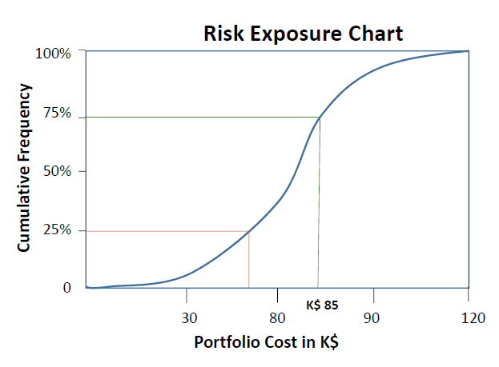

**Risk Management Plan**

* Portfolio management risks may be identified by anyone in the organization
* The portfolio risk management plan describes how risk management is structured
* and performed in the portfolio. It includes:
  + Methodology
  + Roles and responsibilities
  + Risk measures
  + Frequency
  + Risk categories
  + Risk response
* Risks may arise from either external or internal sources

**Risk Management Plan**

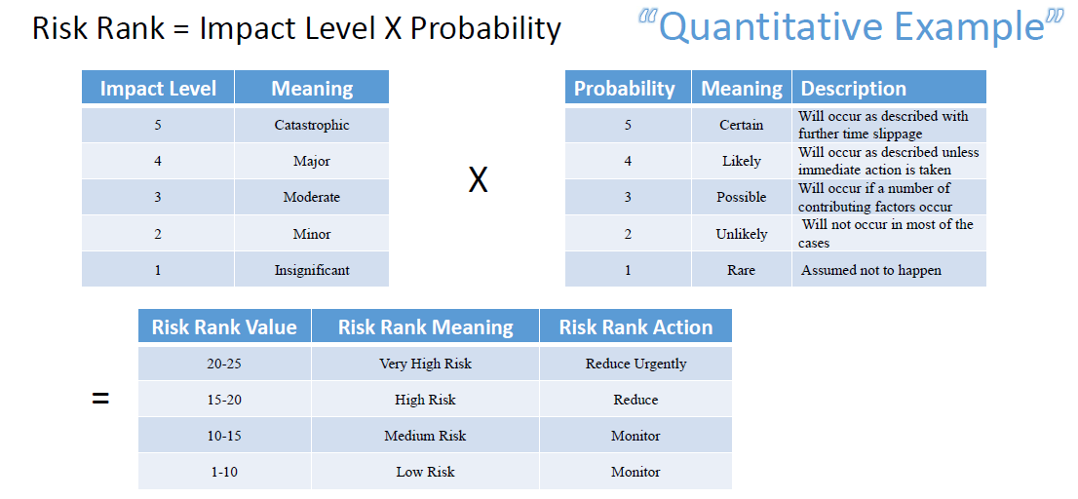

**Risk Management Plan**

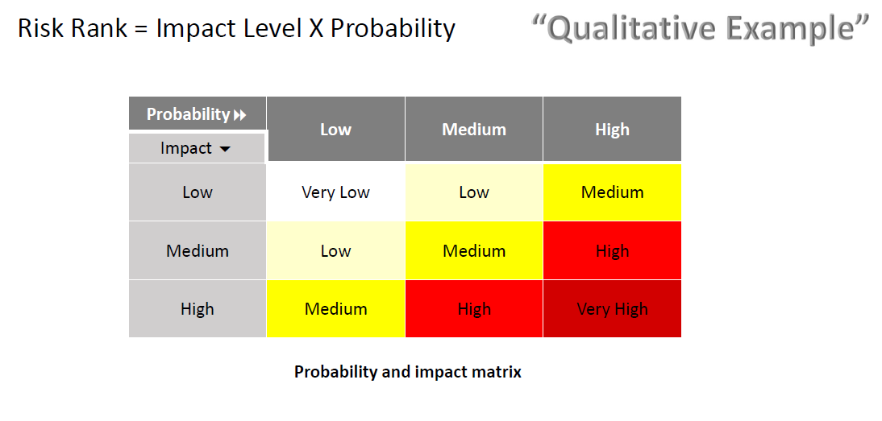

**Manage Portfolio Risks**

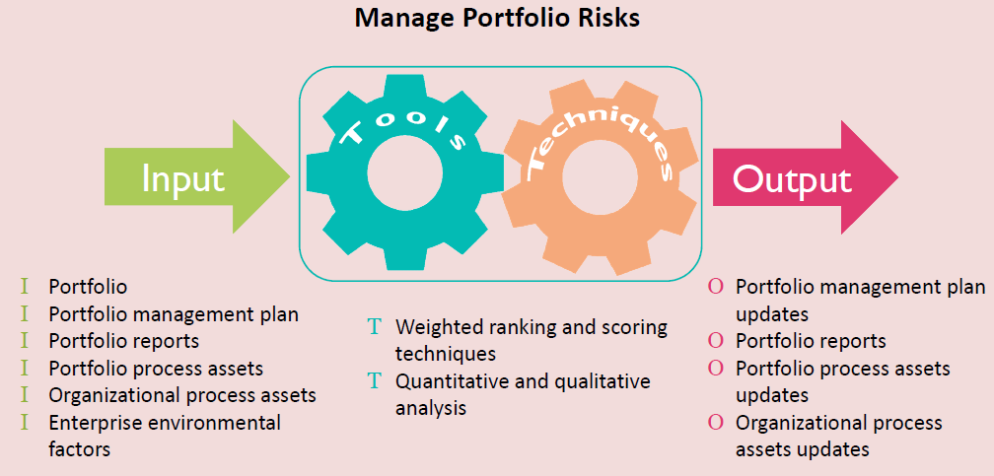

**Portfolio Risks and Issues**

* Portfolio risk register
* Identified risks
* Risk owner
* Risk category
* Probability and impact assessment
* Potential response
* Risk triggers
* Portfolio issues are documented in the issue register

**Manage Portfolio Risks - Risk Register**

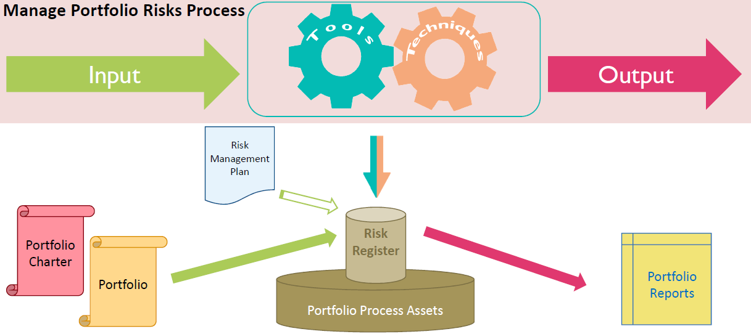

**Quantitative and Qualitative Analyses**

* Quantitative analysis
* Net present value (NPV), estimated net present value (ENPV)
* Payback or payback period (PBP)
* Return on investment (ROI)
* Internal rate of return (IRR)
* Qualitative analysis
* Sensitivity analysis
* Modeling and simulation
* Investment choice analysis

**Sensitivity analysis**

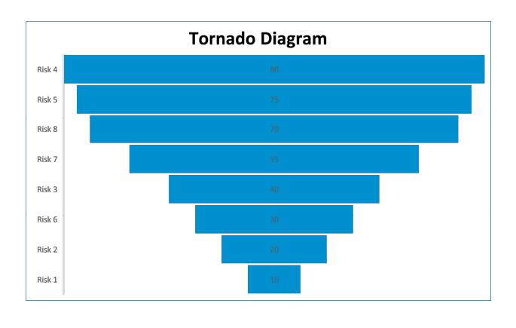

# 7. Portfolio Glossary

